- New Jersey Traffic

Train engineers are not mad and not causing cancellations, union says
11
Updated on July 18, 2017 at 1:44 PM Posted on July 18, 2017 at 1:33 PM
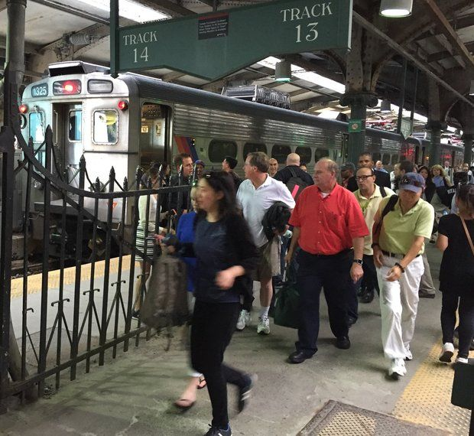
Commuters change trains in Hoboken after the wrong track was announced for their rush hour train last week. Riders said the train they originally boarded was canceled due to a crew shortage. (Larry Higgs | NJ Advance Media for NJ.com)
51 shares
By Larry Higgs
lhiggs@njadvancemedia.com,
NJ Advance Media for NJ.com
Union officials are denying that NJ Transit engineers did not show up for work starting last week to protest a new rail schedule, an action that caused canceled and packed trains.
An NJ Transit official had said that engineers used a loophole that allows them 48 hours to pick a new assignment before a schedule change occurs.
"It's taking advantage of having two days off and taking time to pick an assignment," said the NJ Transit official, who was not authorized to talk to the media about this issue. "They're taking their sweet time picking an assignment."
But James P. Brown, Brotherhood of Locomotive Engineers general chairman, said that there is an engineer shortage and the Penn Station New York track project used up workers on the "extra" list, who substitute when an engineer is sick or can't come to work.
The track project put trains out of position, not allowing a crew to operate trains "back to back" in a round trip.
"It created more jobs, which takes people off the extra list," Brown said. "It's that, a mass exodus of guys from the railroad, and people who have days off. Some people are working their two days off."
NJ Transit needs to replace approximately 25 to 30 engineers, he said.
Selecting work assignments happened several weeks ago and isn't a factor, he said.
"The guys are not disgruntled with the schedule, the work forces are spread out," Brown said. "What's happening is we're shorthanded and the track work in New York makes matters worse."
NJ Transit Twitter alerts cited crew shortages for canceled trains, including suspension of the Princeton shuttle.
NJ TRANSIT - NEC @NJTRANSIT_NEC
(1of2) Princeton Shuttle (Dinky) service remains suspended as a result of no engineer. Substitute bus service is being provided.
4:09 AM - 18 Jul 2017

Cancellations forced commuters to crowd on other rush hour trains.
Mark Quiles, whose train was canceled at Secaucus Junction on Sunday night, had to take Uber instead.
"I ended up spending $25.70, plus tip, to get to the parking lot at Glen Rock BoroughHall, so I could drive home to Hawthorne," he said. "This last minute, rude decision left dozens of people stranded and confused. NJ Transit employees could not explain the last minute notice."
Larry Higgs
✔ @CommutingLarry
No-show #NJTransit engineers force rush hour train cancellations #njcommute http://www.nj.com/traffic/index.ssf/2017/07/no-show_nj_transit_engineers_force_some_rush_hour.html … pic.twitter.com/hUg8aWZQ5G

Andersen Silva @andersensilva
For what it's worth, at least four #NJTransit MBPJ trains were canceled yesterday (Sunday) due to "manpower shortage," too. @NJTransit
7:07 PM - 17 Jul 2017 · Paramus, NJ
Larry Higgs may be reached at lhiggs@njadvancemedia.com. Follow him on Twitter @commutinglarry. Find NJ.com on Facebook.

